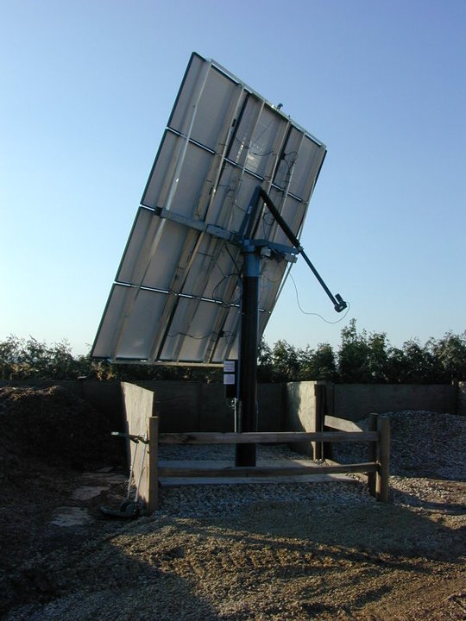
At Pleasant Prairie Greenhouse and Urban Landscaping, we strive to make our entire operation more energy-efficient with the use of solar energy. We respect the environment, and we're constantly working toward contributing to our own sustainability.

- We generate our own heat with solar hot water collectors and biofuel boilers. Our state-of-the-art system uses Photovoltaic solar panels mounted on a tracking frame to produce up to 2.4 kilowatts of DC electricity.

- The tracking frame automatically positions the panels to actively follow the sun as it moves across the sky. Since the panels are constantly positioned at an angle of 90 degrees to the sun, we can maximize the amount of electricity we produce.

- We produce our own heat for our greenhouse via solar hot water collectors. A five-panel solar-evacuated tube collector captures the sun’s energy and then warms a solution in closed loop piping to a temperature between 100 and 130 degrees Fahrenheit. The solution is then transported into a storage system until it can be utilized overnight.

- We minimize energy costs by only heating one section of our greenhouse in winter. It is equipped with efficient radiant floor heating, which works in synchronicity with our solar system.

- We conserve electricity through the use of fluorescent lights.

- Our greenhouses have roll-up sides to cut down increase natural ventilation and decrease the use of fans in summer, and the north walls of our winter production area are well insulated to reduce heat loss in winter.

- Any cooling fans, are powered their own solar panel.

